**TIE DETECTION**

**ABSTRACT:**

This project is based on developing a detection system of whether a person is wearing a tie or not. This concept really helps us with dealing at places or organizations which are really strict about their dress codes. For instance: Schools and Colleges keep a check and balance on dress codes in order to maintain discipline and some work places such as offices etc. really focus on it too. So, I can surely say that this project of ours can help ease this challenge by real time detection using detection technologies.

This project uses the YOLOV4 which stands for “You handiest look as soon as”, object detection algorithm which is implemented by deep neural network architecture.

We will show how the use of this method correctly determines if a tie is wore by a person or not.

We then display that the YOLOV4 also 98% correctly distinguish between distinct states:

* With_tie
* No_tie

##### **INTRODUCTION**

Computer Detection is one of the principal fields of engineered Intelligence that grants computer frameworks and designs to extricate helpful insights from advanced photos, movies, and different apparent contributions for its execution, it utilizes model algorithms basically founded on device acquiring information on and brain networks dependent absolutely upon profound acquiring information on. Computer vision executions comprise of face detection, detection of tie, hand motion gestures, human feeling detection, shading detection, and article detection and grouping, among other excellent bundles. In this documentation, we will discuss YOLOV4, one of the apex algorithms for object detection and class.

Whenever somebody fosters a program or constructs a product, there is consistently an idea behind it or a justification for picking that specific space to deal with. I picked "recognition of regardless of whether somebody is wearing a tie" for certain places to me as well.

Discussing our schools and universities where regalia are explicitly focused on to keep up with discipline. Separate meetings are directed for the regalia of the understudies to be seen by educators and other staff and a major part comprises of regardless of whether an understudy is wearing a tie. This entire interaction is tedious and disappointing now and again in light of the fact that every understudy should be noticed and afterward consistently. The equivalent is with business spots or workplaces and so forth which follow a specific clothing standard. Thus, the venture depended on this idea of constant identification, a product which will recognize regardless of whether an individual is wearing a tie. It will help everybody, make simplicity and save time by identifying a lot of individuals in a limited capacity to focus time.

The significant most advantage of object discovery and Model training systems is that it's more accurate than mortal vision. The mortal brain is astounding so important that it can finish film land dependent on only a couple of particles of data. But it can occasionally also keep us from seeing what's actually there. The complete picture is not always accurate because mortal smarts make hypotheticals.

Object Discovery and Modeling Training systems reply to images grounded only on the data presented and not just particles of it like mortal brain. Although it can make hypotheticals grounded on patterns, it doesn't have the advantage of a mortal brain’s tendency to vault to conclusions that may not be accurate.

Training systems also operates at pixel position at which the mortal brain can’t process. This allows object discovery and modeling systems to give more accurate results. The ultramodern world is enclosed with gigantic millions of digital visual information. To dissect and understand this huge ocean of visual information, there live numerous image analysis ways. The important content of image is the object in the image. There live a significant and essential fashion for labelling.

The introductory provocation behind the content is that it's commodity that will overstate all the physical tasks. It's of interest as it may help humans to reduce task. Object Discovery is a Computer fashion related to computer vision and image processing that deals with discovery cases of semantic objects of a certain class( similar as mortal, structure, or buses ) in digital images and vids. In a Tracking, an object can be defined as anything that's of interest. For illustration, boats on the ocean, fish inside a terrarium. Vehicles on a road and aero planes in the air.e.g we've with tie or no_tie discovery. Representation of objects is veritably important in object discovery and shadowing. There are colorful ways used to represent objects.

The innovation Headways during this stage and over the approaching ordinarily, will decidedly affect society that what the progressions in the set of experiences have delivered. Thus, Why Model Preparation model is significant, as this is a style utilized by machines to distinguish and limit objects in a picture. This is helpful for various activities comparable as tone driving transports or surveillance cameras. Thus, you should grasp this, despite the fact that Item disclosure model preparation might feel like an overwhelming errand. Organizations really must comprehend, how this innovation works to remain cutthroat. By finding opportunity to learn further about these models and how they can be prepared, organizations will be reasonable to utilize this innovation to the it advantage. To really comprehend of all that revelation models preparing bring to the table, it's critical that your preparation information is just about as precise as could be expected.

##### **RELATED WORK**

This study plans to recognize individuals who are not wearing tie and the people who are wearing a tie.

We utilized Head Part Investigation to present an exemplary AI approach for perceiving individuals with tie and without tie. As indicated by the discoveries, an individual without a tie has a higher ID rate.

1. **PROPOSED METHODOLOGY**

The proposed model gives Tie Detection utilizing YOLO V4. The preparation module is additionally split between a few layers, information procurement layer, preprocessing layer preparing layer, validation layer, and correlation of validation results with a limit esteem.

In the preparation module, the information procurement layer contains the pictures dataset, the pictures in this dataset are gathered from various areas. This dataset is required preprocessing, which is acted in preprocessing layer. In preprocessing layer pictures are annotated with the YOLOv4 version. The preprocessed dataset is additionally separated for preparing and validation with a 80% and 20% proportion individually. The YOLOv4 model is imported from the cloud and utilized for preparing subsequent to tweaking. This altered YOLOv4 model prepared the custom dataset and afterward this prepared model is approved utilizing the test dataset. The validation precision is contrasted and the edge on the off chance that the approving exactness meets the limit prerequisites, the model is put away in a data set living in the cloud and on the off chance that the validation precision isn't met the limit standards, then they need more preparation to the dataset to accomplish the ideal exactness.

* 1. ***Dataset:***

This exploration depends on two kinds of the class picture dataset. The one contains pictures of people that wear tie and the inferior contains pictures of an individual that doesn't wear tie. The dataset contains an all-out 400 number of pictures, containing individuals wearing tie and without tie. The pictures are gathered from various different areas like a shopping centers, parks, markets schools, universities, and universities. The dataset is annotated utilizing labeling programming, and named every one of the pictures in view of modified two classes 1) with_tie 2) no_tie in YOLOv4 design. Figure-2 shows the strategy of information annotation utilizing labeling programming. During the time spent information annotation, a text document is created containing five segments' information as displayed in figure-3. The main segment contains the data in regards to classes, 0 methods with_tie class, and 1 method no-tie. Class. The section second and third having the middle x and focus y of the bouncing boxes and the last two segments contain the width and level of the jumping boxes.

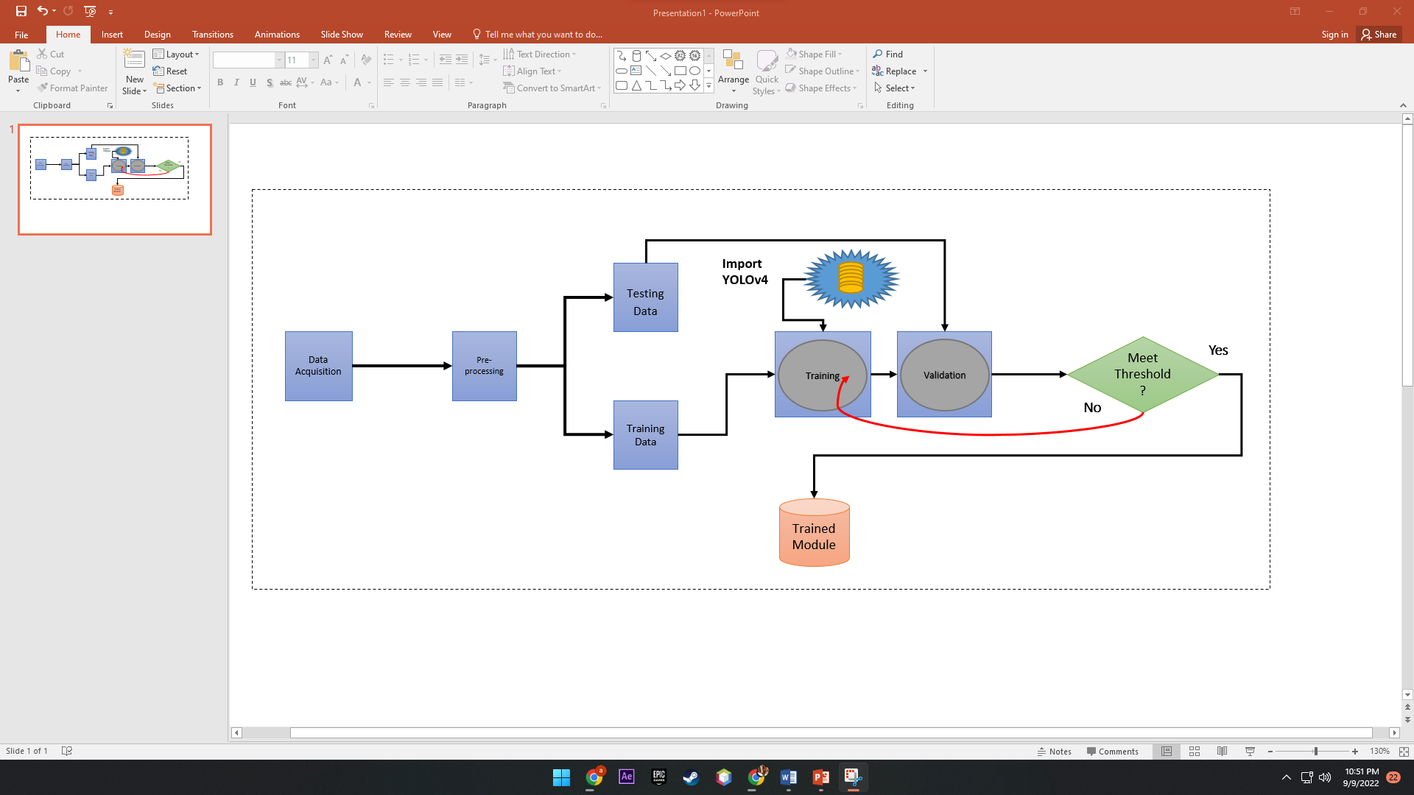

***Figure-1: The proposed Tie Detector using Transfer Learning) model***

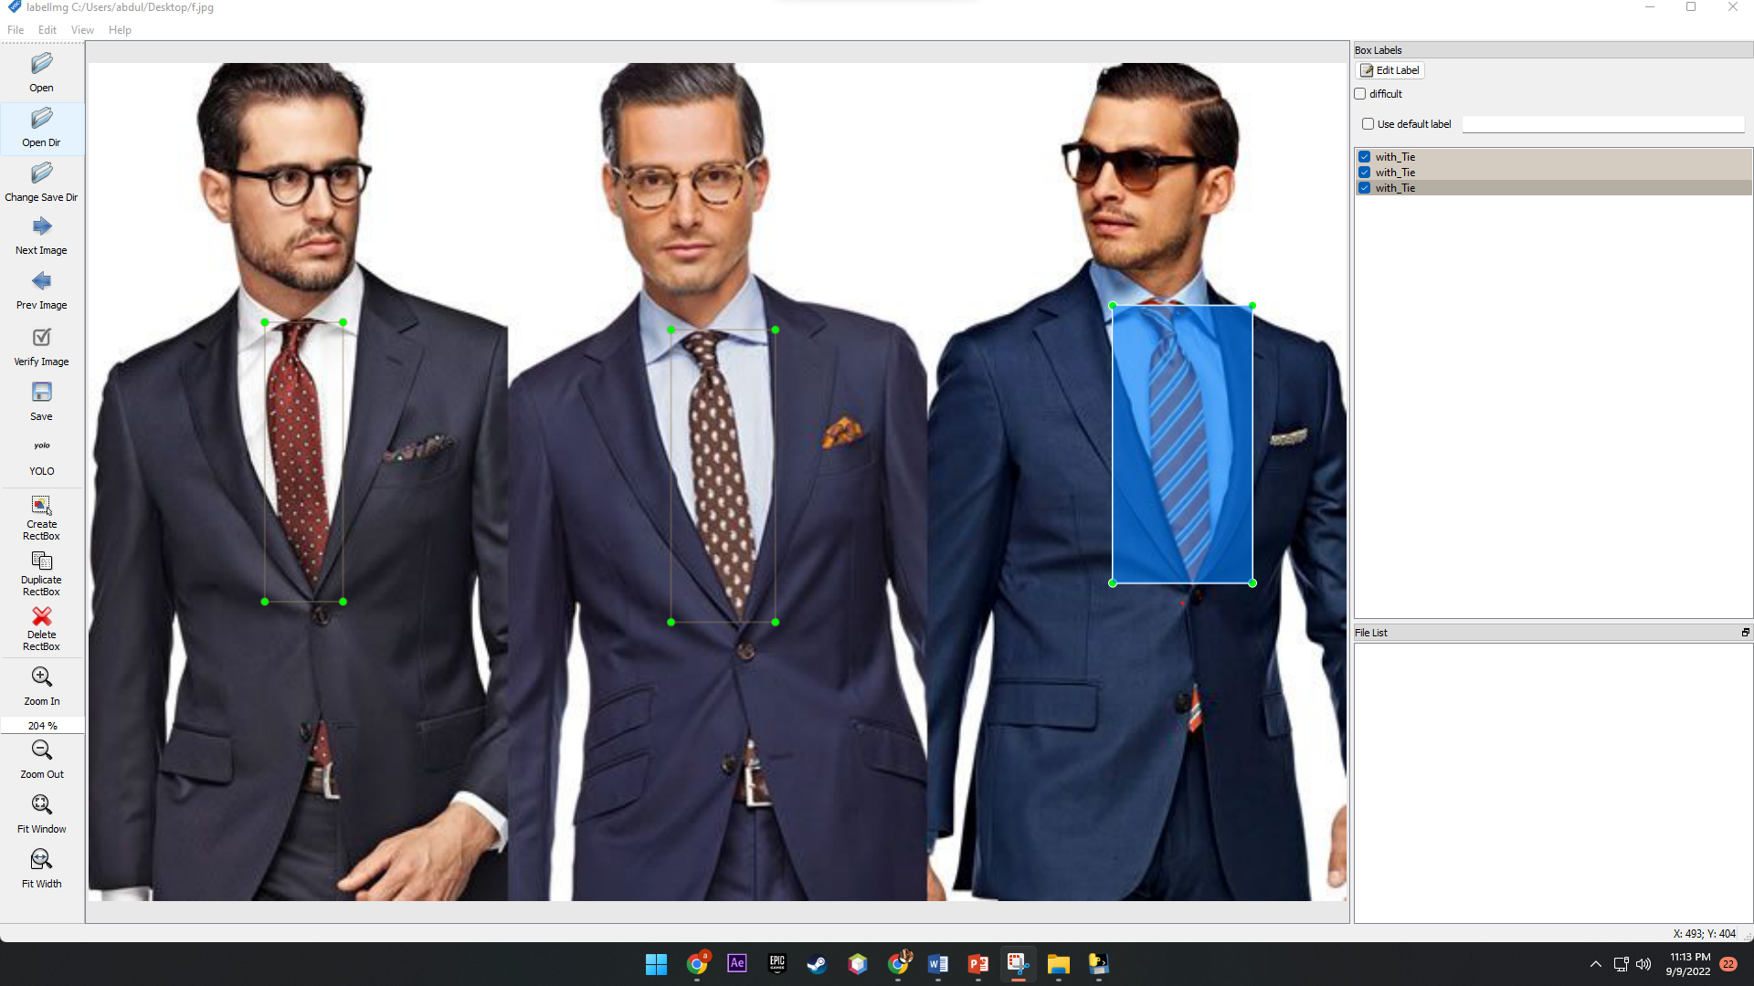

***Figure-2: Dataset annotation for the proposed model***

* 1. ***YOLOv4:***

YOLO (You most effective look once), is a set of rules that detects and recognizes exceptional items in an image (in actual-time). In item Detection, object Detection, item Detection, and item Detection proudly delivered a brand new approach to the arena of item detection algorithms. A paper reference is supplied via item Detection. The model takes an photograph or a chain of images (video frames) as enter and returns critical functions which include x-coordinates, y-coordinates, magnificence call, and a dependable score (opportunity). YOLO promises superior studying competencies, higher speed and high accuracy in comparison to different algorithms. It is also small in length.

YOLOv4 is that the most forward-thinking and up to date variety of your just Look Once (YOLO) approaches. Prior to plunging into the YOLOv4 method, we should first investigate the origination of picture classification and article confinement. One of the principal notable PC vision errands is picture classification, targeting relegating each picture during a dataset to something like one of the 2 or extra classes. For example, an image classification algorithmic rule is likewise intended to differentiate pictures containing canines from ones with felines. It addresses the inquiry "What is that the fundamental article during this image?" On the off chance that you didn't exclusively have to shape utilization of criminal investigator work the presence of an article, but conjointly of finding any place this item is inside the picture, you'll have the option to construct utilization of the system alluded to as protest confinement. This changes our inquiry to "What is that the primary article during this picture and any place is it?" Now, the premier high level, and intriguing, the strategy is object detection.

In most genuine circumstances, we wish our model to go on the far side perceiving and finding just a single item and sight different articles inside a similar picture. Object detection will essentially this and draw in a problematic bouncing box around each individual item. The inquiry lands up being "What are the articles during this picture and any place are they?" It will notice elective vehicles, traffic signals, walkers, signs, and elective entities that might impact driving way of behaving. Because of this activity that happens harmonizing with the truth, it's labeled period object detection.

In this examination YOLOv4 algorithm for facial covering detection by utilizing Darknet is a spine of the YOLOv4 model. In the proposed Tie Detection utilizing the YOLOv4 algorithm is applied to the dataset to get better exactness and immediately find the outcomes that an individual is wearing a facial covering or not. In object detection, we ordinarily utilize a jumping box to distinguish the objective position. The jumping box is a rectangular box characterized by the x and y directions of the upper left corner,

After the training process, the prepared model is put away in the event that it meets the ideal sifted for this situation 90% worth is set as the edge. On the off chance that the prepared model isn't address the limit esteem the issue more training to accomplish the necessary precision esteem. The prepared model is put away for additional application.

* 1. ***Detection Module:***

The trained model can be utilized in any real-life application for tie detection. This model can be applied in such associations where wearing the tie is obligatory for the keeping up with of dress code (tie detection), Like schools, schools, universities, shopping centers, associations, Medical clinics, and so on it can likewise be pertinent in synthetic enterprises where cover wearing is necessary.

##### **EXPERIMENTS AND RESULTS**

The dataset utilized for the training contains 400 pictures of various sizes. The YOLOv4 model secret all pictures into a similar size width level 416 same for both.

The channel size is set 3 during the customizing YOLOv4 process and the learning rate is 0.0001 is used. The 4,000 iterations (max_batches) are used to predict two classes (With Mask and Without Mask) and steps=3200, 3600 as per policy to 80% and 90% of max_batches. The mean average precision in the training process is 90.% with a loss rate of 0.49 as shown in figure-4.

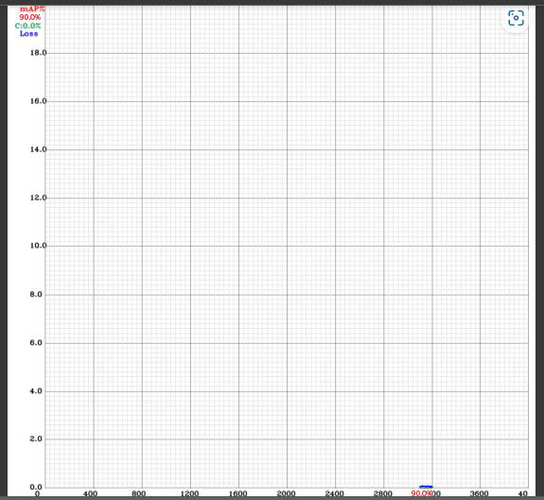

***Figure-4: The training process of the proposed model by using YOLOv4***

* 1. ***Performance Metrics***

To measure the performance of a proposed model is based on the counts of testing records correctly identified and incorrectly identified by the proposed FMDTL model. The accuracy of the proposed FMDTL model provides the statistics about how many images are properly classified in the confusion matrix by using the trained proposed FMDTL model is shown in equation-1.

|  |  |  |
| --- | --- | --- |
|  |  | 1 |

The False Negative Rate (FNR) or Error Rate or Miss Rate of the proposed model is found by equation-2 in the confusion matrix.

|  |  |  |
| --- | --- | --- |
| FNR |  | 2 |

Equation-3 represents the True Positive Rate (TPR), Sensitivity or Recall

|  |  |  |
| --- | --- | --- |
| TPR |  | 3 |

True Negative Rate (TNR) or Specificity measure metric is calculated by equation-4.

|  |  |  |
| --- | --- | --- |
| TNR |  | 4 |

The Positive Predictive Value or precision is measured by equation-5.

|  |  |  |
| --- | --- | --- |
|  |  | 5 |

The Negative Predictive Value (NPV) of the proposed model. is measured by the equation-6

|  |  |  |
| --- | --- | --- |
|  |  | 6 |

Equation-7 represents the False Positive Rate (FPR) of Fall-Out of the proposed FMDTL model.

|  |  |  |
| --- | --- | --- |
|  |  | 7 |

The False Discovery Rate (FDR) of the proposed model is shown in equation-8.

|  |  |  |
| --- | --- | --- |
|  |  | 8 |

The import metric to evaluate the proposed model is F1-Score. It is finding by taking the Geometric Mean of and as shown in Equation-9

|  |  |  |
| --- | --- | --- |
|  |  | 9 |

Intersection over Union is the performance measure metric used in Deep Leaning like YOLO, CNN, R-CNN, etc. it is calculated as the intersection of the ground bounding box and predicted bounding box divided by the union of both. The ground bounding box is marked the desired area at the image during the process of annotation and the prediction bounding box is marked by the training model during the process of prediction. Equation-1 shows the intersection over the union of bounding boxes.

|  |  |
| --- | --- |
|  |  |
|  | 10 |

The higher value of the IoU consider as the better accuracy of the model and the 0.5 value is used as a threshold. The interpretation of IoU results is shown in figure-5.

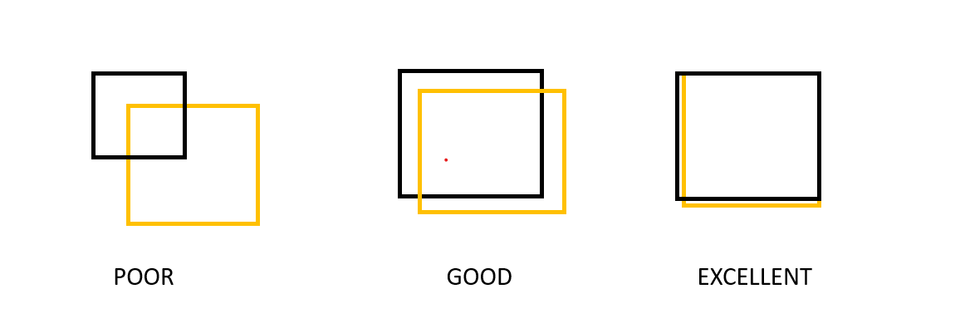

***Figure-5: The performance measure of IoU***

IoU is also used to eliminate the duplicated bounding box for the desired object. For this process sort all objects/predictions in descending order concerning their confidence. The IoU of the object will be high if two bounding boxes pointing the same object then a higher confidence bundling box is chosen and reject the other bonding box. On the other hand, if the value of IoU is low then the mean of two bonding is taken.

***Figure-6: IoU with Ground Bounding Boxes and Predicted Bounding Boxes***

The figure-6 represents the IoU with Ground Bounding Boxes and Predicted Bounding Boxes in the proposed model training.

In this article, the performance of the proposed model is calculated by using Accuracy, FNR, TPR, TNR, PPV, NPV, FPR, FDR, F1-Score, and IoU as shown in table-2 based on the confusion matrix shown in table-1.

The figure-7 and figure-8 shown the results of the prediction of the proposed FMDTL models. The prediction accuracy of the mask and without mask at least 98% as shown in figure 7 &8

|  |  |  |  |
| --- | --- | --- | --- |
|  |  |  |  |
|  |  |  |  |
| ***Figure-7: Prediction results of without tie*** | | | |
|  |  |  |  |
|  |  |  |  |
| ***Figure-8: Prediction results of with tie*** | | | |

|  |  |  |  |  |
| --- | --- | --- | --- | --- |
| *Table-1: Confusion matrix of the validation of the proposed model using YOLO v4* | | | | |
| Proposed FMDTL Model with 20% validation dataset | | | | |
| Total number of samples= 112 | | Predicted Output (Oe, Oo) | | |
| Input | Expected Output (Ew, Eo) | Ow (with_tie) | Oo (no_tie) | Total |
| Ew ( with_tie) | 17 | 10 | 27‬ |
| Eo (no_tie) | 3 | 82 | 85 |
| Total |  | 20 | 92 | 112‬ |

The description of the confusion matrix shown in table-1 are shown below:

True Positive ( ) = 17; The model accurately classified 17 images in with mask class out of 27 images. True Negative = 82; images from the without mask class were successfully categorized out of 85 images. False Positive ()= 3; The model mistakenly identified 3 images without a mask as with mask class. False Negative ( )= 10; Consequently, the model mistakenly identified 10 images of with mask class as without mask class

|  |  |  |  |  |  |  |  |  |  |  |
| --- | --- | --- | --- | --- | --- | --- | --- | --- | --- | --- |
| ***Table-2: Performance evaluation of proposed model with different statistical*** | | | | | | | | | |  |
| **Results** | **Accuracy** | **FNR**  **Miss Rate** | **TPR**  **Sensitivity** | **TNR**  **Specificity** | **PPV**  **Precision** | **NPV** | **FPR** | **FDR** | **F1-Score** | **IoU** |
| **Validation** | 0.8839  88.39% | 0.1161  11.61% | 0.6296  62.96% | 0.9647  96.47% | 0.8500  85.00% | 0.8913  89.13% | 0.03529  3.53% | 0.15000  15.00% | 0.7234  72.34% | 0.6655  66.55% |

##### **CONCLUSION AND FUTURE WORK**

This Project did object identification using YoloV4 algorithm for the item recognition of individuals wearing a tie and of the people who are not wearing a tie. A contraption that really does surely proceed as is expressed in this report became built. It features the adequacy of containerization of obligations during preparing, where picture handling and accumulation happens succinctly and effectively in discrete administrations.

This technique will offer smooth individual association highlight recuperate the leaned toward pictures. This paper besides give preliminary outcomes on unique methodologies for object identification and unmistakable confirmation and ponders every procedure for their efficiencies.

In future the model can be prepared by expanding the pictures in the dataset and making tremendous dataset so that it can identified at various areas and with various climate. It would be exceptionally useful at various spaces.

**Limitation:**

1. It can detect tie on people.
2. In the vast majority of cases, it successfully detected the presence of tie on subjects who were not directly facing the camera.